CSA0501-DATABASE MANAGEMENT SYSTEMS
LAB EXPERIMENTS DATE: 17-08-2026

EXPERIMENT 15 - DCL COMMANDS – GRANT, REVOKE

AIM:

To learn and implement DCL commands such as GRANT and REVOKE to control user privileges on the existing database tables.

PROCEDURE:

Create a new database user.

Grant privileges to the user for the required tables.

Check the privileges granted to the user.

Revoke a privilege from the user.

Verify the privileges after revoking.

PROGRAM :
CREATE USER 'labuser'@'localhost'
IDENTIFIED BY 'Lab@123';

GRANT SELECT, INSERT, UPDATE
ON INTERN.INTERN
TO 'labuser'@'localhost';

GRANT SELECT
ON INTERN.DEPARTMENT
TO 'labuser'@'localhost';

GRANT SELECT
ON INTERN.FACULTY
TO 'labuser'@'localhost';

GRANT SELECT
ON INTERN.PROJECTS
TO 'labuser'@'localhost';

GRANT SELECT
ON INTERN.INTERN_EMP_INFO
TO 'labuser'@'localhost';

SHOW GRANTS FOR 'labuser'@'localhost';

OUTPUT:
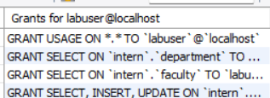

REVOKE INSERT,UPDATE
ON INTERN.INTERN
FROM 'labuser'@'localhost';
OUTPUT:
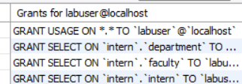
REVOKE INSERT,UPDATE,SELECT
ON INTERN.INTERN
FROM 'labuser'@'localhost';
SHOW GRANTS FOR 'labuser'@'localhost';
OUTPUT:
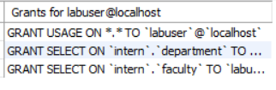

RESULT:
Thus the DCL commands GRANT and REVOKE SQL executed successfully.

